# ASSIGNMENT(25-08-2025)

Submitted by: Srividya Arul Raju

Roll number: 23KQ5A0206

1.To check power of the number in python.

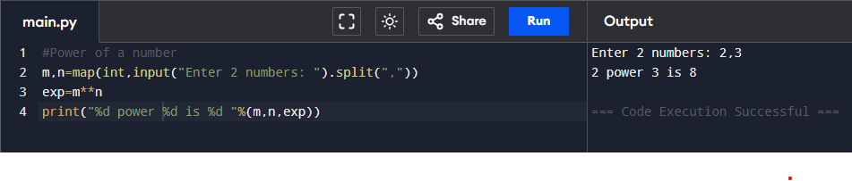

2.To check the divisors of a number.

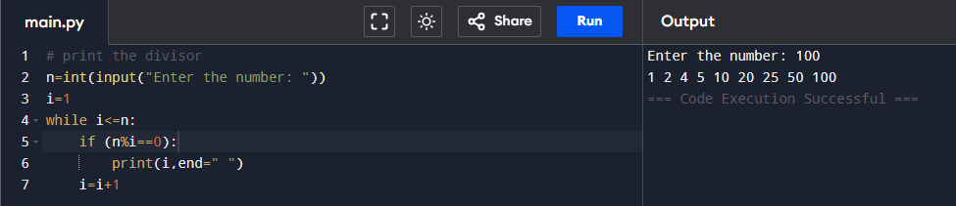

3.To check the perfect number.

